**Circuit Designs CSIS 2810**

**Basic Gates: And, Or Not**

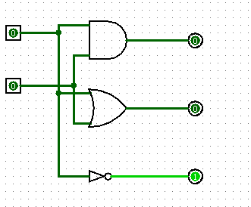

**1 bit MUX(Multiplexer)**

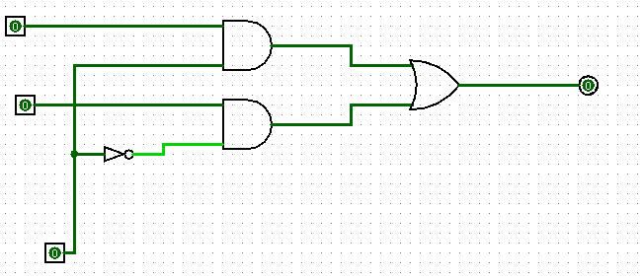

**3 bit MUX (Gates and MUX part; also uses a splitter and multi-bit IO)**

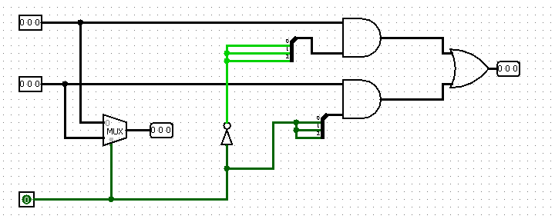

**D Flip Flop(Gates and D FlipFlop part, uses a constant)**

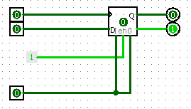

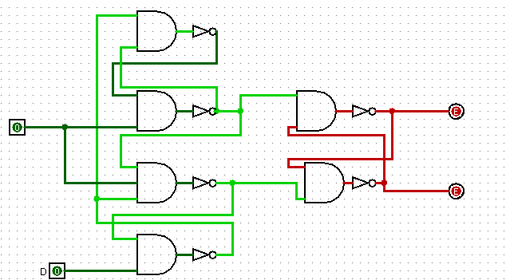

**4 Bit Register(Gates and Part)**

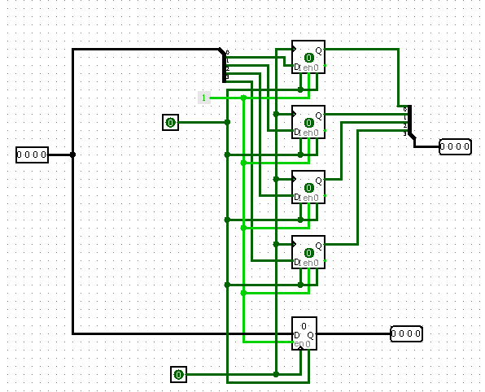

**PC(Program Counter, uses memory)**

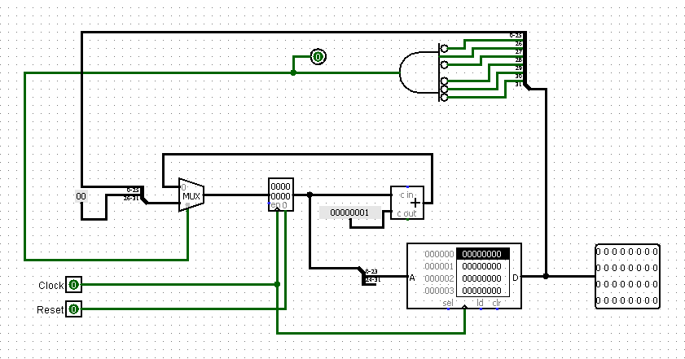

**RF Subpart(Register File Subpart)**

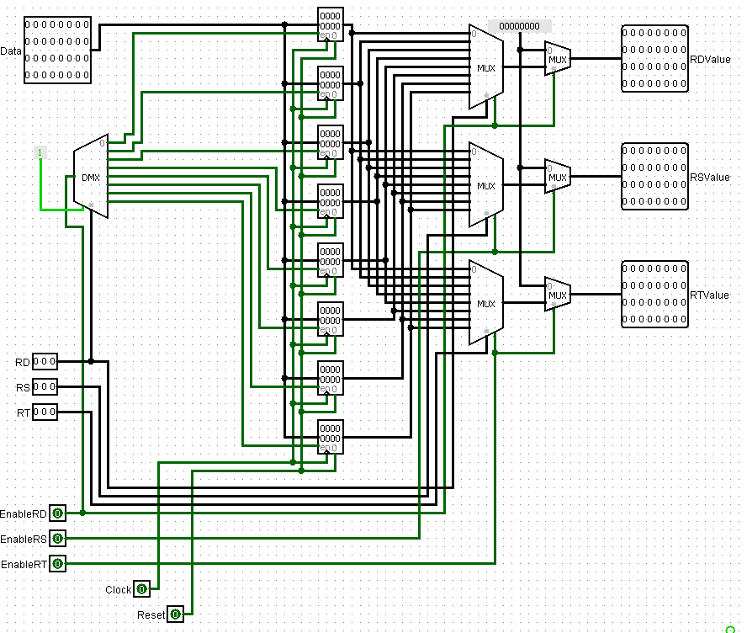

**RF(Register File)**

